CHAPTER 1 - DECLARATION AND ACCESS CONTROL

Legal Identifiers

- Identifiers must start with a letter, a currency character ($), or a connecting character such as the underscore ( _ ). Identifiers cannot start with a number!

- After the first character, identifiers can contain any combination of letters, currency characters, connecting characters, or numbers.

- In practice, there is no limit to the number of characters an identifier can contain.

- You can't use a Java keyword as an identifier. Table 1-1 lists all of the Java keywords including one new one for 5.0, enum.

- Identifiers in Java are case-sensitive; foo and FOO are two different identifiers

Java Keywords

abstract boolean break byte case catch
char class const continue default do
double else extends final finally float
for goto if implements import instanceof
int interface long native new package
private protected public return short static
strictfp super switch synchronized this throw
throws transient try void volatile while
assert enum

Classes and interfaces

The first letter should be capitalized, and if several words are linked together to form the name, the first letter of the inner words should be uppercase (a format that's sometimes called "camelCase").

For classes, the names should typically be nouns. For example:

Dog
Account
PrintWriter

For interfaces, the names should typically be adjectives like

Runnable
Serializable

 Methods

The first letter should be lowercase, and then normal camelCase rules should be used. In addition, the names should typically be verb-noun pairs.

For example:
getBalance
doCalculation
setCustomerName

 Variables

Like methods, the camelCase format should be used, starting with a lowercase letter. Sun recommends short, meaningful names, which sounds good to us. Some examples:

buttonWidth
accountBalance
myString

 Constants

Java constants are created by marking variables static and final. They should be named using uppercase letters with underscore characters as separators:

MIN_HEIGHT

First, JavaBeans are Java classes that have properties. For our purposes, think of
properties as private instance variables. Since they're private, the only way they can be accessed from outside of their class is through methods in the class. The methods that change a property's value are called setter methods, and the methods that retrieve a property's value are called getter methods.

Source File Declaration Rules

- There can be only one public class per source code file.

- Comments can appear at the beginning or end of any line in the source code file; they are independent of any of the positioning rules discussed here.

- If there is a public class in a file, the name of the file must match the name of the public class. For example, a class declared as public class Dog { } must be in a source code file named Dog.java.

- If the class is part of a package, the package statement must be the first line in the source code file, before any import statements that may be present.

- If there are import statements, they must go between the package statement (if there is one) and the class declaration. If there isn't a package statement, then the import statement(s) must be the first line(s) in the source code file. If there are no package or import statements, the class declaration must be the first line in the source code file.

- Import and package statements apply to all classes within a source code file. In other words, there's no way to declare multiple classes in a file and have them in different packages, or use different imports.

- A file can have more than one nonpublic class.

- Files with no public classes can have a name that does not match any of the classes in the file.

- Access modifiers: public, protected, private and default.

- Non-access modifiers (including strictfp, final, and abstract).

Default Access

Think of default access as package-level access, because a class with default access can be seen only by classes within the same package. Compile error if class in package A tries to access other class in package B having default access.

Public Access

A class declaration with the public keyword gives all classes from all packages access to the public class. In other words, all classes in the Java Universe (JU) have access to a public class. Don't forget, though, that if a public class you're trying to use is in a different package from the class you're writing, you'll still need to import the public class.

Final Classes

When used in a class declaration, the final keyword means the class can't be subclassed. In other words, no other class can ever extend (inherit from) a final class, and any attempts to do so will give you a compiler error.

Abstract Classes

An abstract class can never be instantiated. Its sole purpose, mission in life, is to be extended (subclassed).

abstract class Car {
private double price;
private String model;
private String year;
public abstract void goFast();
public abstract void goUpHill();
public abstract void impressNeighbors();
// Additional, important, and serious code goes here

Notice that the methods marked abstract end in a semicolon rather than curly braces. Always remember that if even a single method is abstract, the whole class must be declared abstract. You can, however, put nonabstract methods in an abstract class. You can't mark a class as both abstract and final. They have nearly opposite meanings. An abstract class must be subclassed, whereas a final class must not be subclassed. If you see this combination of abstract and final modifiers, used for a class or method declaration, the code will not compile.

Declaring an Interface

Interfaces can be implemented by any class, from any inheritance tree. This lets you take radically different classes and give them a common characteristic.

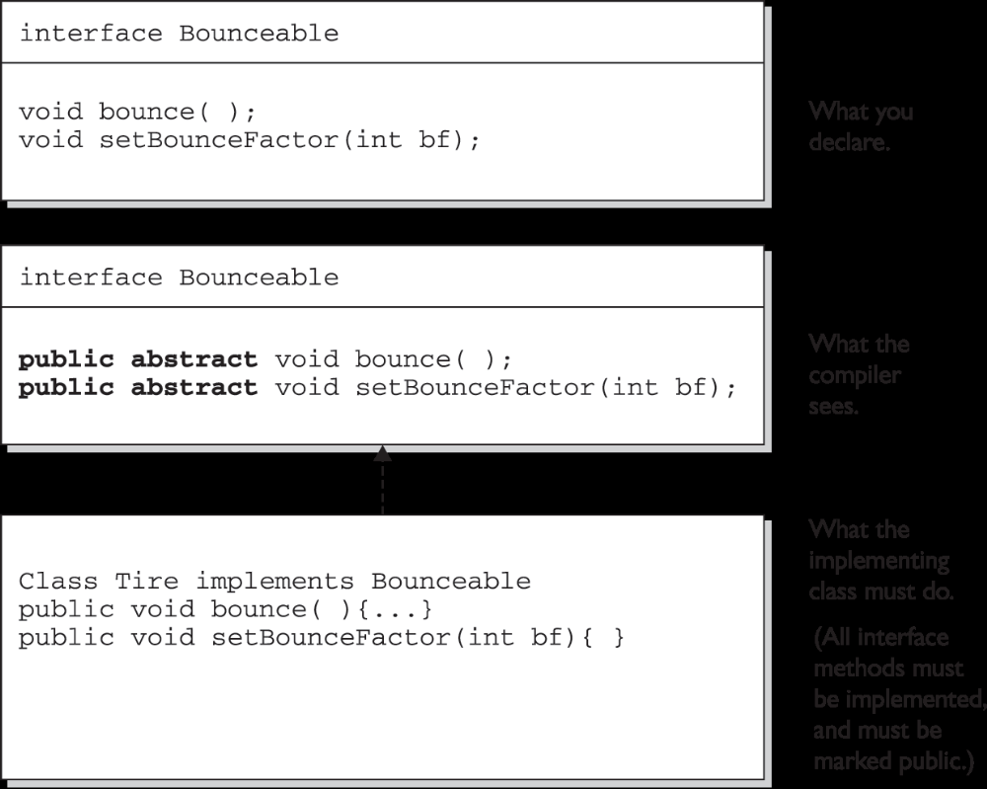

Think of an interface as a 100-percent abstract class. Like an abstract class, an interface defines abstract methods that take the following form:

abstract void bounce(); // Ends with a semicolon rather than curly braces

But while an abstract class can define both abstract and non-abstract methods, an interface can have only abstract methods. Another way interfaces differ from abstract classes is that interfaces have very little flexibility in how the methods and variables defined in the interface are declared. These rules are strict:

- All interface methods are implicitly public and abstract. In other words, you do not need to actually type the public or abstract modifiers in the method declaration, but the method is still always public and abstract.

- All variables defined in an interface must be public, static, and final— in other words, interfaces can declare only constants, not instance variables.

- Interface methods must not be static.

- Because interface methods are abstract, they cannot be marked final, strictfp, or native.

- An interface can extend one or more other interfaces.

- An interface cannot extend anything but another interface.

- An interface cannot implement another interface or class.

- An interface must be declared with the keyword interface.

- Interface types can be used polymorphically.

The following is a legal interface declaration:

public abstract interface Rollable { }

Typing in the abstract modifier is considered redundant; interfaces are implicitly abstract whether you type abstract or not. You just need to know that both of these declarations are legal, and functionally identical:

public abstract interface Rollable { }
public interface Rollable { }

The public modifier is required if you want the interface to have public rather than default access.

For example, the following five method declarations, if declared within their own interfaces, are legal and identical!

void bounce();
public void bounce();
abstract void bounce();
public abstract void bounce();
abstract public void bounce();

The following interface method declarations won't compile:

final void bounce(); // final and abstract can never be used together, and abstract is implied
static void bounce(); // interfaces define instance methods
private void bounce(); // interface methods are always public
protected void bounce(); // (same as above)

Declaring Interface Constants

You need to remember one key rule for interface constants. They must always be public static final So that sounds simple, right? After all, interface constants are no different from any other publicly accessible constants, so they obviously must be declared public, static, and final. As interface constants are defined in an interface, they don't have to be declared as public, static, or final. They must be public, static, and final, but you don't have to actually declare them that way. Just as interface methods are always public and abstract whether you say so in the code or not, any variable defined in an interface must be—and implicitly is—a public constant.

interface Foo {
int BAR = 42;
void go();
}

class Zap implements Foo {
public void go() {
BAR = 27; // Constant can not be changed !!
}
}

Look for interface definitions that define constants, but without explicitly using the required modifiers. For example, the following are all identical:

public int x = 1; // Looks non-static and non-final, but isn't!
int x = 1; // Looks default, non-final, non-static, but isn't!
static int x = 1; // Doesn't show final or public
final int x = 1; // Doesn't show static or public
public static int x = 1; // Doesn't show final
public final int x = 1; // Doesn't show static
static final int x = 1 // Doesn't show public
public static final int x = 1; // what you get implicitly

Any combination of the required (but implicit) modifiers is legal, as is using no modifiers at all! On the exam, you can expect to see questions you won’t be able to answer correctly unless you know, for example, that an interface variable is final and can never be given a value by the implementing (or any other) class.

Members

Methods and instance (nonlocal) variables are collectively known as members. You can modify a member with both access and nonaccess modifiers, and you have more modifiers to choose from (and combine) than when you're declaring a class. Whereas a class can use just two of the four access control levels (default or public), members can use all four:

public
protected
default
private

Public Members

When a method or variable member is declared public, it means all other classes,
regardless of the package they belong to, can access the member (assuming the class
itself is visible). Remember, if you see a method invoked (or a variable accessed) without the dot operator (.), it means the method or variable belongs to the class where you see that code. It also means that the method or variable is implicitly being accessed using the this reference. So in the preceding code, the call to doRooThings() in the Cloo class could also have been written as this.doRooThings().

Private Members

Members marked private can't be accessed by code in any class other than the class in which the private member was declared.

Although you're allowed to mark instance variables as public, in practice it's nearly always best to keep all variables private or protected. If variables need to be changed, set, or read, programmers should use public accessor methods, so that code in any other class has to ask to get or set a variable (by going through a method), rather than access it directly. JavaBean-compliant accessor methods take the form get<propertyName> or, for booleans, is<propertyName> and set<propertyName>, and provide a place to check and/or validate before returning or modifying a value.

Protected and Default Members

The protected and default access control levels are almost identical, but with one
critical difference. A default member may be accessed only if the class accessing the
member belongs to the same package, whereas a protected member can be accessed
(through inheritance) by a subclass even if the subclass is in a different package.Default and protected behavior differ only when we talk about subclasses.
But what does it mean for a subclass-outside-the-package to have access to a
superclass (parent) member? It means the subclass inherits the member. It does not,
however, mean the subclass-outside-the-package can access the member using a reference to an instance of the superclass. In other words, protected = inheritance.
Protected does not mean that the subclass can treat the protected superclass member
as though it were public. So if the subclass-outside-the-package gets a reference to the superclass (by, for example, creating an instance of the superclass somewhere in the subclass' code), the subclass cannot use the dot operator on the superclass reference to access the protected member.
To a subclass-outside-the-package, a protected member might as well be default (or even private), when the subclass is using a reference to the superclass. The subclass can see the protected member only through inheritance.
A protected member has essentially package-level or default access to all classes except for subclasses. We've seen that subclasses outside the package can inherit a protected member. Finally, we've seen that subclasses outside the package can't use a superclass reference to access a protected member.
For a subclass outside the package, the protected member can be accessed only through inheritance. when a subclass-outside-the-package inherits a protected member, the member is essentially private inside the subclass, such that only the subclass and its subclasses can access it.

Can access modifiers be applied to local variables? NO! There is never a case where an access modifier can be applied to a local variable, so watch out for code like the following:

class Foo {
void doStuff() {
private int x = 7;
this.doMore(x);
}
}

Local variables
You can be certain that any local variable declared with an access modifier will
not compile. In fact, there is only one modifier that can ever be applied to local variables—final.

Abstract methods
Any class that extends an abstract class must implement all abstract methods
of the superclass, unless the subclass is also abstract.

The rule is this:
The first concrete subclass of an abstract class must implement all abstract methods of the superclass.

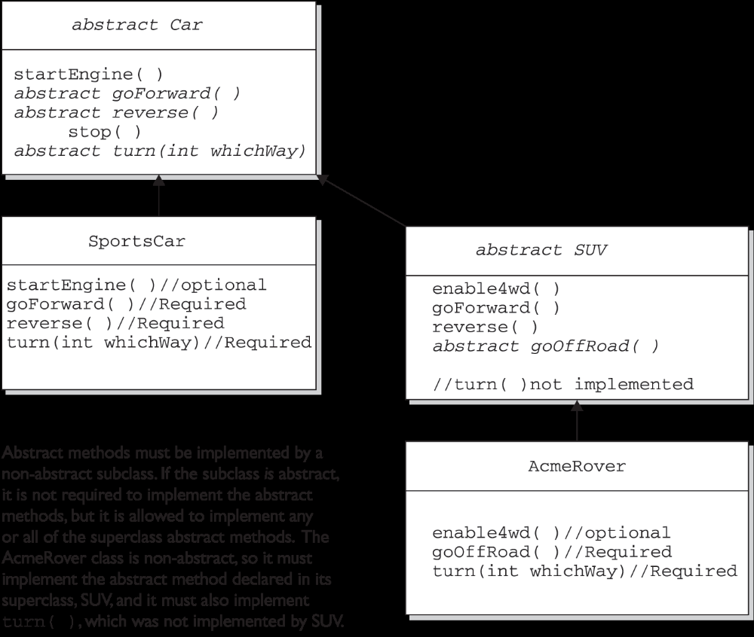

Look for concrete classes that don't provide method implementations for abstract methods of the superclass. The following code won't compile:

public abstract class A {
abstract void foo();
}

class B extends A {
void foo(int I) { }
}

Class B won't compile because it doesn't implement the inherited abstract method foo(). Although the foo(int I) method in class B might appear to be an implementation of the superclass' abstract method, it is simply an overloaded method (a method using the same identifier, but different arguments), so it doesn't fulfill the requirements for implementing the superclass' abstract method.

A method can never, ever, ever be marked as both abstract and final, or both abstract and private. Also the abstract modifier can never be combined with the static modifier.

abstract static void doStuff(); // Compile error !!

The synchronized modifier can be applied only to methods—not variables, not classes, just methods.

You should also know that the synchronized modifier can be paired with any of the three access modifier keywords.

Native methods

The native modifier indicates that a method is implemented in platform-dependent
code, often in C. native is a modifier (thus a reserved keyword) and that native can be applied only to methods—not classes, not variables, just methods. Note that a native method's body must be a semicolon (;) (like abstract methods),indicating that the implementation is omitted.

Strictfp
Remember, strictfp forces floating points (and any floating-point operations) to adhere to the IEEE 754 standard. With strictfp, you can predict how your floating points will behave regardless of the underlying platform the JVM is running on. strictfp can modify a class or method declaration, and that a variable can never be declared strictfp.

Declaration rules for var-args

- When you declare a var-arg parameter, you must specify the type of the argument(s) this parameter of your method can receive. (This can be a primitive type or an object type.)

- Basic syntax To declare a method using a var-arg parameter, you follow the type with an ellipsis (...), a space, and then the name of the array that will hold the parameters received.

- Other parameters It's legal to have other parameters in a method that uses a var-arg.

- Var-args limits The var-arg must be the last parameter in the method's signature, and you can have only one var-arg in a method.

Let's look at some legal and illegal var-arg declarations:

Legal:

void doStuff(int... x) { } // expects from 0 to many ints as parameters
void doStuff2(char c, int... x) { } // expects first a char, then 0 to many ints
void doStuff3(Animal... animal) { } // 0 to many Animals

Illegal:

void doStuff4(int x...) { } // bad syntax
void doStuff5(int... x, char... y) { } // too many var-args
void doStuff6(String... s, byte b) { } // var-arg must be last

Constructor Declarations
In Java, objects are constructed. Every time you make a new object, at least one
constructor is invoked. Every class has a constructor, although if you don't create one explicitly, the compiler will build one for you.

- A key difference is that a constructor can't ever, ever, ever, have a return type…ever! Constructor declarations can however have all of the normal access modifiers, and they can take arguments (including var-args), just like methods.

- constructors is that they must have the same name as the class in which they are declared.

- Constructors can't be marked static (they are after all associated with object instantiation), they can't be marked final or abstract (because they can't be overridden).

class Foo2 {
// legal constructors
Foo2() { }
private Foo2(byte b) { }
Foo2(int x) { }
Foo2(int x, int... y) { }

// illegal constructors
void Foo2() { } // it's a method, not a constructor
Foo() { } // not a method or a constructor
Foo2(short s); // looks like an abstract method
static Foo2(float f) { } // can't be static
final Foo2(long x) { } // can't be final
abstract Foo2(char c) { } // can't be abstract
Foo2(int... x, int t) { } // bad var-arg syntax
}

Variable Declarations

There are two types of variables in Java:

Primitives A primitive can be one of eight types: char, boolean, byte,short, int, long, double, or float. Once a primitive has been declared, its primitive type can never change, although in most cases its value can change.

Reference variables A reference variable is used to refer to (or access) an object. A reference variable is declared to be of a specific type and that type can never be changed. A reference variable can be used to refer to any object of the declared type, or of a subtype of the declared type (a compatible type).

Instance variables:
- Can use any of the four access levels (which means they can be marked with any of the three access modifiers)

- Can be marked final

- Can be marked transient

- Cannot be marked abstract

- Cannot be marked synchronized

- Cannot be marked strictfp

- Cannot be marked native

- Cannot be marked static, because then they'd become class variables.

 Local variables:
Before a local variable can be used, it must be initialized with a value. For instance:

class TestServer {
public void logIn() {
int count = 10;
}
}
The compiler will reject any code that tries to use a local variable that hasn't been
assigned a value, because—unlike instance variables—local variables don't get
default values.
It is possible to declare a local variable with the same name as an instance
variable. It's known as shadowing,

Wrong code

The following (wrong) code is trying to set an instance variable's value using a Parameter:

class Foo {
int size = 27;
public void setSize(int size) {
size = size; // ??? which size equals which size???
}
}

Right code

class Foo {
int size = 27;
public void setSize(int size) {
this.size = size; // this.size means the current object's
// instance variable, size. The size
// on the right is the parameter
}
}

Array declaration

Declaring an Array of Primitives

Int [ ] key; // Square brackets before name (recommended)
int key [ ]; // Square brackets after name (legal but less readable)

Declaring an Array of Object References

Thread[ ] threads; // Recommended
Thread threads [ ]; // Legal but less readable

We can also declare multidimensional arrays, which are in fact arrays of arrays. This can be done in the following manner:

String[ ][ ][ ] occupantName; // 3D
String[ ] ManagerName [ ]; // 2D

It is never legal to include the size of the array in your declaration.Yes, we know you can do that in some other languages, which is why you might see a question or two that include code similar to the following:

int[5] scores;

The preceding code won’t compile. Remember, the JVM doesn’t allocate space until you actually instantiate the array object. That’s when size matters.

A reference variable marked final can't ever be reassigned to refer to a different object. The data within the object can be modified, but the reference variable cannot be changed. In other words, a final reference still allows you to modify the state of the object it refers to, but you can't modify the reference variable to make it refer to a different object.
Burn this in: there are no final objects, only final references.

Transient Variables

If you mark an instance variable as transient, you're telling the JVM to skip (ignore) this variable when you attempt to serialize the object containing it.

Volatile Variables

The volatile modifier tells the JVM that a thread accessing the variable must always reconcile its own private copy of the variable with the master copy in memory. As with transient, it can be applied only to instance variables.

Static Variables and Methods

The static modifier is used to create variables and methods that will exist independently of any instances created for the class. In other words, static members exist before you ever make a new instance of a class, and there will be only one copy of the static member regardless of the number of instances of that class. In other words, all instances of a given class share the same value for any given static variable.

Things you can mark as static:

- Methods
- Variables
- A class nested within another class, but not within a method .
- Initialization blocks

Things you can't mark as static:

- Constructors (makes no sense; a constructor is used only to create instances)
- Classes (unless they are nested)
- Interfaces
- Method local inner classes
- Inner class methods and instance variables
- Local variables

Declaring Enums
It's not required that enum constants be in all caps, but borrowing from the Sun code convention that constants are named in caps, it's a good idea.

Enums can be declared as their own separate class, or as a class member, however they must not be declared within a method!

Declaring an enum outside a class:

enum CoffeeSize { BIG, HUGE, OVERWHELMING } // this cannot be private or Protected

class Coffee {
CoffeeSize size;
}
public class CoffeeTest1 {
public static void main(String[] args) {
Coffee drink = new Coffee();
drink.size = CoffeeSize.BIG; // enum outside class
}
}

The preceding code can be part of a single file. (Remember, the file must be named
CoffeeTest1.java because that's the name of the public class in the file.) The key point to remember is that the enum can be declared with only the public or default modifier, just like a non-inner class. Here's an example of

Declaring an enum inside a class

class Coffee2 {
enum CoffeeSize {BIG, HUGE, OVERWHELMING }
CoffeeSize size;
}
public class CoffeeTest2 {
public static void main(String[] args) {
Coffee2 drink = new Coffee2();
drink.size = Coffee2.CoffeeSize.BIG; // enclosing class name required
}
}

To make it more confusing for you, the Java language designers made it optional to put a semicolon at the end of the enum declaration.

enum really is a special kind of class. You can add constructors, instance variables, methods, and something really strange known as a constant specific class body.

enum CoffeeSize {
BIG(8), HUGE(10), OVERWHELMING(16);
// the arguments after the enum value are "passed" as values to the constructor
CoffeeSize(int ounces) {
this.ounces = ounces; // assign the value to an instance variable
}
private int ounces; // an instance variable each enum value has
public int getOunces() {
return ounces;
}
}
class Coffee {
CoffeeSize size; // each instance of Coffee has-a CoffeeSize enum
public static void main(String[] args) {
Coffee drink1 = new Coffee();
drink1.size = CoffeeSize.BIG;
Coffee drink2 = new Coffee();
drink2.size = CoffeeSize.OVERWHELMING;
System.out.println(drink1.size.getOunces()); // prints 8
System.out.println(drink2.size.getOunces()); // prints 16
}
}

The key points to remember about enum constructors are

- You can NEVER invoke an enum constructor directly. The enum constructor is invoked automatically, with the arguments you define after the constant value. For example, BIG(8) invokes the CoffeeSize constructor that takes an int, passing the int literal 8 to the constructor.

- You can define more than one argument to the constructor, and you can overload the enum constructors, just as you can overload a normal class constructor.

Imagine this scenario: you want enums to have two methods—one for ounces and one for lid code (a String). Now imagine that most coffee sizes use the same lid code, "B", but the OVERWHELMING size uses type "A". You can define a getLidCode() method in the CoffeeSize enum that returns "B", but then you need a way to override it for OVERWHELMING. You don't want to do some hard-tomaintain if/then code in the getLidCode() method, so the best approach might be to somehow have the OVERWHELMING constant override the getLidCode() method.

This looks strange, but you need to understand the basic declaration rules:

enum CoffeeSize {
BIG(8),
HUGE(10),
OVERWHELMING(16) { // start a code block that defines the "body" for this constant
public String getLidCode() { // override the method defined in CoffeeSize
return "A";
}
}; // <-- the semicolon is REQUIRED when you have a body
CoffeeSize(int ounces) {
this.ounces = ounces;
}
private int ounces;
public int getOunces() {
return ounces;
}
public String getLidCode() { // this method is overridden by the oVERWHELMING constant
return "B"; // the default value we want to return for CoffeeSize constants
}
}

